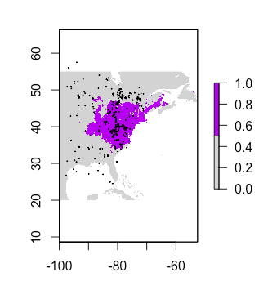Current:

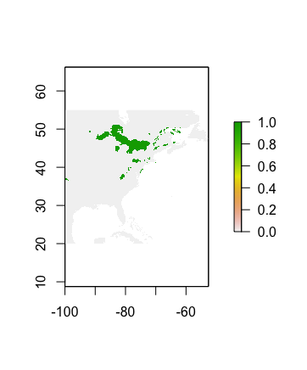

Future:

Looking at these graphs, it is clear that there is a distinct difference between the current and future species projection for *Epitheca cynosura*. The current projections show a vast coverage of the species across the eastern side of the country, which is great. However, the future model shows a significantly different distribution. It seems that most of the species is pushed north which, at the very least, follows the predictions of climate change. Also significantly different in this projection is the overall location of the species. It appears there is very little overlap with where they are now versus where they will be. This is also intriguing because it poses the question of why they would do this and why they would completely change their geographic distribution. Will climate change be this devastating on their current distribution? I think the differences here are pretty interesting and it makes me wonder how accurate this modeling is.